Green Chemicals: The Ultimate Win-Win Solution Amidst Europe's Energy Crisis
Abhinandan Nabera, Ioan-Robert Istrate, Antonio J. Martín, Javier Pérez-Ramírez* and Gonzalo Guillén-Gosálbez*
ETH Zürich
The chemical industry strongly depends on fossil fuels, constituting the highest energy demand among all sectors. It is responsible for approximately 5.6 Gt CO₂-eq yr^{–1}, which accounts for nearly 10% of global greenhouse gas emissions.^{[1]} Ammonia and methanol are essential platform chemicals that serve as primary building blocks for producing valuable products with diverse applications. Currently, 60–70% of global ammonia and methanol production depends on syngas obtained primarily through steam reforming of natural gas, contributing to GHG emissions of 0.8 Gt CO₂-eq yr^{–1}.^{[1]} Previous studies have demonstrated the technical feasibility and potential climate benefits of using low-carbon or green hydrogen in ammonia and methanol production.^{[2]} However, the fundamental barrier towards implementation has always been the higher production costs than their fossil-based counterparts. The current geopolitical scenario has dramatically altered this situation, leading to a surge in natural gas and electricity prices, resulting in higher production costs for fossil-based ammonia and methanol production in Europe. Consequently, low-carbon ammonia and methanol production have the potential to become economically (in addition to environmentally) appealing. In this study, we employ process simulation and techno-economic assessment tools to examine whether the ongoing energy crisis in Europe has altered the cost dynamics of fossil and green ammonia and methanol production. According to our study, the production costs for fossil ammonia and methanol were estimated to be around 2.4 and 2.2 USD kg^{–1}, respectively, during the peak of natural gas spot prices in August 2022 (Fig. 1). These costs were approximately 3–4 times higher than the same period in 2021. However, based on our production cost estimates, green ammonia and methanol produced through on-shore wind electricity via water electrolysis became economically competitive during the same period (Fig. 1). Wind-based ammonia, in particular, exhibited a significant advantage, with costs ranging from 1.3 to 1.6 USD kg^{–1}, outperforming its fossil counterpart (blue shaded area in Fig. 1a). These results highlight the tremendous potential for Europe to lead the grand transition towards a sustainable chemical industry, given the evident uncertainty in natural gas supply and the price fluctuations.
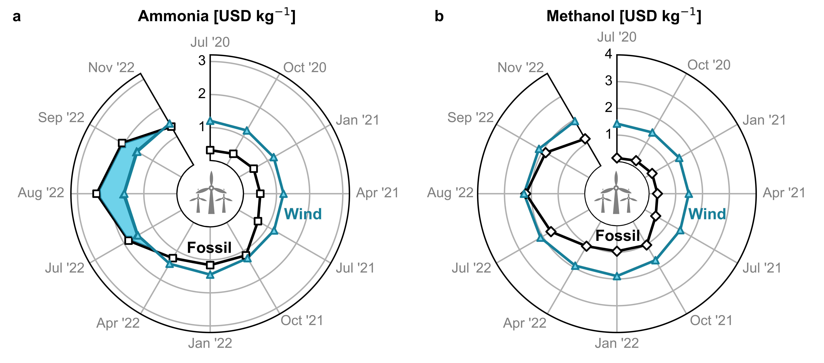
Fig. 1 Temporal evolution of estimated production cost for wind-based (a) ammonia and (b) methanol in Europe compared with their fossil counterpart in USD kg^{–1}. The blue shaded area in (a) demonstrates the economic viability of wind-based ammonia.
[1] F. Bauer, J. P. Tilsted, S. Pfister, C. Oberschelp, V. Kulionis, Curr. Opin. Chem. Eng. 2023, 39, 100881.
[2] Á. Galán-Martín, V. Tulus, I. Díaz, C. Pozo, J. Pérez-Ramírez, G. Guillén-Gosálbez, One Earth 2021, 4, 565.

